SCUBA-2 Block Specification
fsfb_ctrl

Table of Contents

1. Block Overview 3
1.1 Block Location and Block Interface within System 3
1.2 Block Functionality / Features 3
1.3 Block Dataflow 4
2. Block Interfaces 5
2.1 Interface Signal Description 5
2.2 Interface Protocol and Timing 5
3. High-Level Description 7
3.1 State Machine Descriptions 7
3.2 Special Optimizations 8
4. Files of the Block 9
4.1 Source Code 9
4.1.1 Source1.vhd 9
4.2 Header Code 9
4.2.1 Header1.vhd 9
5. Naming Conventions Used 10

Block Overview

Block Location and Block Interface within System
The fsfb_ctrl is a component in flux_loop_ctrl. The flux_loop_ctrl is instantiated eight times, one per channel, in the flux_loop block of a Readout Card.
As illustrated in Figure 1, the fsfb_ctrl interfaces with the following blocks:
- The DAC of the Readout card;
- The frame_timing block on the Readout card;
- The fsfb_calc in the flux_loop_ctrl.

DAC
frame_timing
fsfb_ctrl
flux_loop_ctrl
fsfb_calc
Figure 1: Location of fsfb_ctrl in the System.

Block Functionality / Features
The fsfb_ctrl block receives the 32-bit data, fsfb_ctrl_dat_i(31..0), to be applied to DAC. Since DAC input data is only 14 bits, fsfb_ctrl selects only 14 bits from the input data, e.g., fsfb_ctrl_dat_i(25..12). The selection is based on a generic value that has a default value of (13..0). If not in lock mode, fsfb_ctrl sends the data as is to the DAC and issues a DAC clock enable signal under the control of dac_dat_en_i from the frame_timing block. However, if it is in lock mode indicated by the fsfb_calc block, fsfb_ctrl runs the input data through a conversion map. The conversion map is to convert the input 2’s complement to a binary output. This conversion map needs to know the polarity of conversion in the ADC. This latter information is provided to fsfb_ctrl using a generic value. Finally, the converted data is sent to the DAC and a DAC clock is asserted under the control of the dac_dat_en_i from the frame_timing block.

Block Dataflow
Figure 2 represents the dataflow for fsfb_ctrl.

Conversion Map
From fsfb_calc
fsfb_ctrl_lock_en_i
To DAC
F
F
F
F
Figure 2: The fsfb_ctrl block dataflow.

Block Interfaces

Interface Signal Description
- Interface Signals
Signal | Description | Direction
Global Signals
rst_i | Global reset | in
clk_50_i | Global clock | in
Frame_timing Interface
dac_dat_en_i | Indicates the window to send data to the DAC | in
fsfb_calc Interface
fsfb_ctrl_dat_i | Input data from upstream block | in
fsfb_ctrl_dat_rdy_i | Asserted for one clock cycle when the data input is valid | in
fsfb_ctrl_lock_en_i | When high, it indicates that the flux_loop_ctrl is in lock mode | in
DAC Interface
dac_dat_o | Data to the DAC | out
dac_clk_o | Enable clock to DAC | out

Interface Protocol and Timing
Figure 3 illustrates the interface protocol timing.

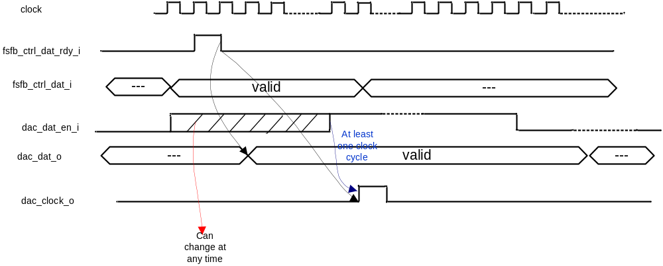
Figure 3: Timing for Interface Signals.
As shown in Figure 3, dac_dat_en_i can change at any time with respect to fsfb_ctrl_dat_rdy_i. Therefore, dac_clock_o is asserted if both fsfb_ctrl_dat_rdy_i and dac_dat_en_i have been asserted.

High-Level Description

State Machine Descriptions
The Algorithmic State Machine (ASM) for the fsfb_ctrl is shown in Figure 4.

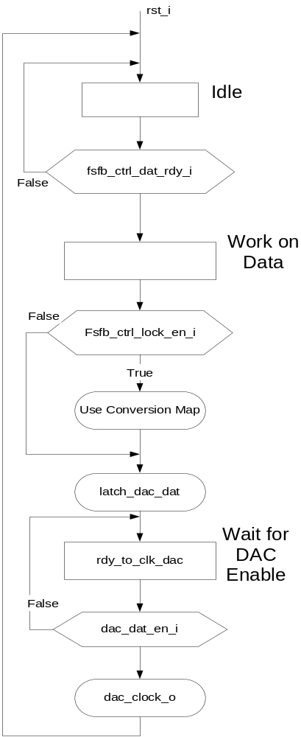
Figure 4: The fsfb_ctrl Algorithmic State Machine.

A timing diagram representation of the control signals for the fsfb_ctrl is shown in Figure 5.

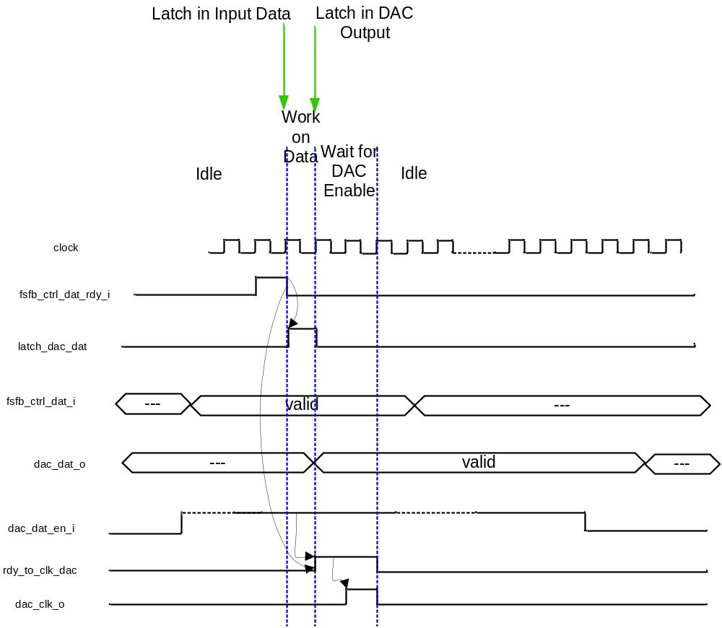
Figure 5: The fsfb_ctrl Control Signals Timing.

Special Optimizations

Files of the Block

Source Code

Source1.vhd

Header Code

Header1.vhd

Naming Conventions Used

